**SOLAR INVERTER DERATE DETECTION**

A solar inverter is a device which converts and aggregates the current generated by the solar cells (DC output) to a form which is fit for consumption (AC output, at the right voltage and frequency). A solar farm typically has multiple inverters, each catering to a certain number of solar cells. Usually, all inverters are identical in specification, and therefore, are supposed to behave identically.

The key data that is collected from the inverter is the instantaneous AC power output. This is collected as a time series at fixed intervals. One of the first insights about the health of an inverter can be gained by comparing the output of one inverter with the others which are part of the same solar farm. If the output is different, the next level of insights can be gained by categorizing this different behaviour into multiple known failure/anomaly modes by performing pattern matching.

One such anomaly is ‘Inverter Derate’. When inverter(s) is/are derated, the output from those inverter(s) will be lower than the outputs from the other inverters by a noticeable extent. But, the pattern of the anomalous inverter still needs to be very similar to that of the other inverters.

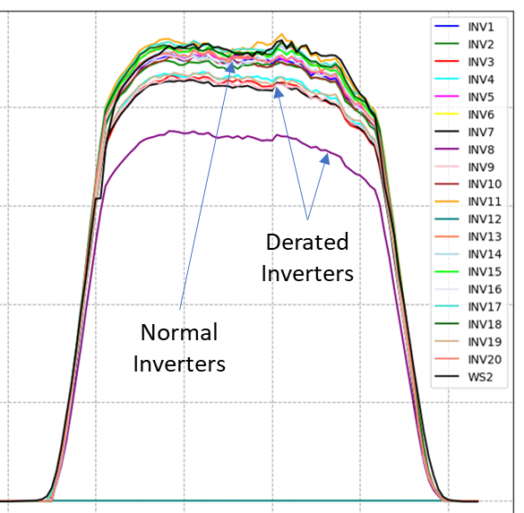

**The task of this coding assignment is to identify the derated inverter(s) on a day to day basis and report out the timestamps corresponding to the anomalies.**

The power output from the inverters are obviously driven by the irradiation from the sun. Therefore, the output shows a strong correlation with the irradiation data, which is also provided to you. This data may or may not be useful to you.

There are many other anomalies present in the given data – like flatlines during the day (the inverter is completely down), sudden dips in the output, etc. You are encouraged to create a ‘mean-differences’-based filter or any other filter to clean out these other anomalies.